Rath Senior ConNEXTions Center
Educational Meeting
9:00 a.m. Tuesday, October 11, 2022
College Heights United Methodist Church
934 South Blvd, Lakeland, FL 33803

2023 Annual Open Enrollment for Medicare
- Why do those TV ads say Medicare people can "get money back?'
- How will the Inflation Recovery Act affect my Medicare prescriptions?
- Do most people get a Medicare Advantage plan or stay with the government option?
- What should you review during the Annual Open Enrollment Period that starts October 15th and ends December 7th?

Join us via Zoom or in person to get answers from our Medicare experts.

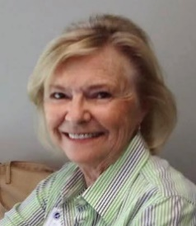
Jean Berken is entering her 14th Medicare Annual Open Enrollment as a SHINE volunteer counselor. She loves sharing her knowledge of Medicare in clear language to help Medicare people make informed decisions. SHINE is a State Health Insurance Assistance Program (SHIP) funded by the federal government. SHIPs provide free, personalized, and unbiased counseling to Medicare members and their families.
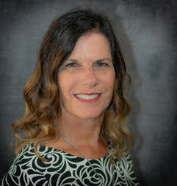
Karen Dean has been an independent insurance agent for 6 years with 15 years working in all aspects of medical offices. She provides her clients with personalized Medicare health insurance solutions. Karen volunteers with VISTE and facilitates faith based senior resource centers.

We hope you can come to our new office for this event. If not, please call the Rath Office or send an email to receive a Zoom invite.

This is an education meeting, no sales or solicitation.

863-220-7002 RathSrConnextions@gmail.com TheRathCenter.org

